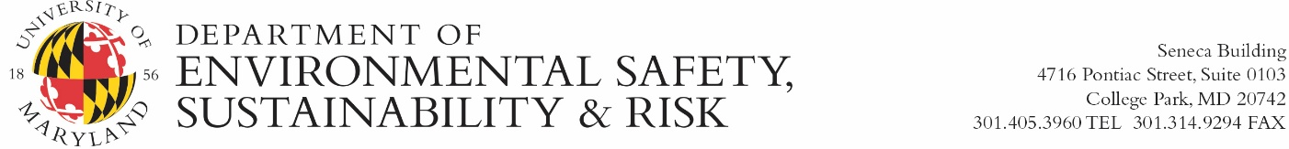

University of Maryland, College Park

Radiation Safety Office

Radioactive Materials Order Form

Use this form to request the purchase of radioactive material. Upon completion of this form, forward a copy to the Radiation Safety Office, Seneca Bldg., 4716 Pontiac St., Ste. 0103. Please email to radiationsafety@umd.edu. Your order will be placed by Radiation Safety staff using the KFS Number you indicate in the space provided. Please note: Radiation Safety does not accept purchasing card numbers for radioactive material orders.
Date | Name of Person Requesting Material
UM KFS Number | Department Phone Number
Business Manager Name (Print) | Business Manager Signature  Sign here, or in lieu of signature include approval statement for KFS transfer in email correspondence.

(Description of item)
Vendor Name | Catalog Number
Product Name | Activity (amount)  ______ uCi ______mCi
PI Name (print) | Estimated Cost (optional)

Radiation Safety will order the material and send a confirmation email to the Principal Investigator with the product cost including shipping fees. All costs incurred will be transferred to the PI using the KFS Number provided above. This request for radioactive material will NOT be processed without a proper signature and description of item. If you have any questions, please contact Radiation Safety at 301-405-3985.

RSO USE: Req#______________ Order/Confirmation #______________ Actual Cost_____________

